This file contains instructions for using new Matrix functionalities:

To add a new matrix we press new matrix button and add matrix in following ways:

Example:----

1. For 1 X 3 matrix-

matrix([1,2,3])

1. For 3 X 3 matrix-

matrix([[1,2,3],[4,5,6],[7,8,9]])

For matrix addition –

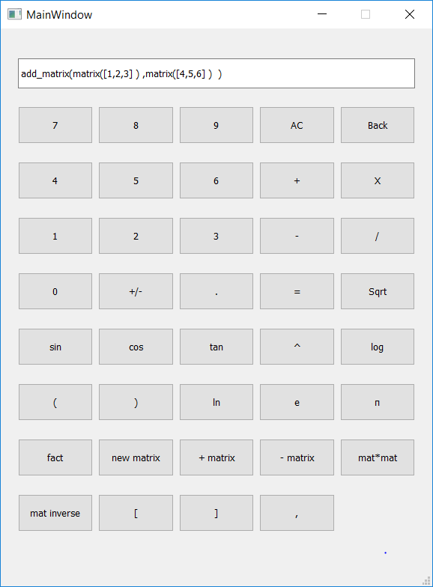

For matrix multiplication:

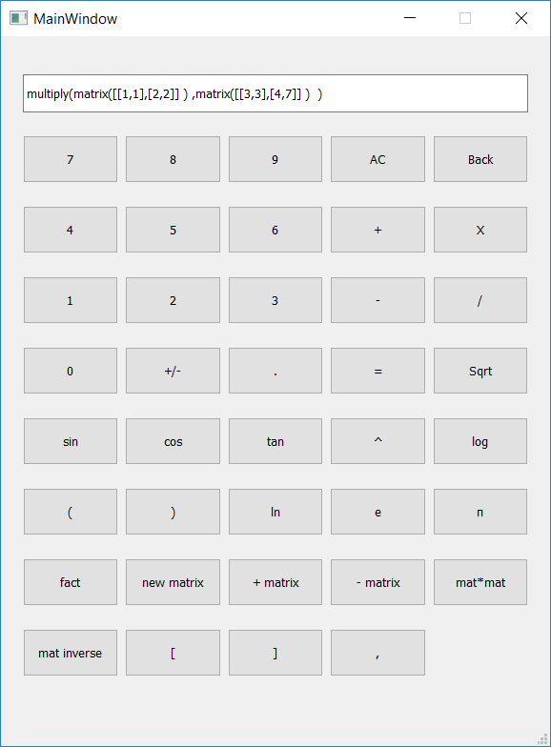

The output for matrix multiplication is:

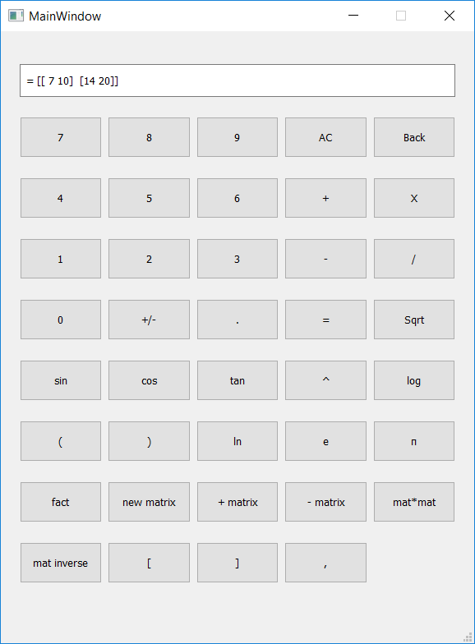

The other features like matrix inverse, subtraction can be used in same way.

----Pratyush Harsh